|  |  |
| --- | --- |
|  |  |
| Operating Systems |  |
| Assignment - 1 | Group 14 Batch – B Sarvesh Shashikumar CB.EN.U4AIE21163    Kalyana Sundaram CB.EN.U4AIE21120  Praneetha K CB.EN.U4AIE21147  Subikksha CB.EN.U4AIE21167  Kaushik Jonnada CB.EN.U4AIE21122 |
|  |  |
|  |  |

Visualization of Process Scheduling In Scratch

The particular type of scheduling we implemented is ‘Round Robin’.

Round Robin Scheduling:

Round Robin scheduling algorithm is type of algorithm where its processes each get a fixed time in the ready state and then in the CPU to execution of that process.

This happens in a cyclic way because there exists a ‘time quantum’. This indicates the maximum amount of time one process can spend in the CPU at a time. If the total time of that process is greater than the time quantum of the schedule, then the remaining part of the process is executed in the next cycle. On the hand, if the process has time lesser than or equal to the time quantum of the particular schedule, the process will execute till its finished and then move on to the next process which is in ready state.

Scratch Implementation:

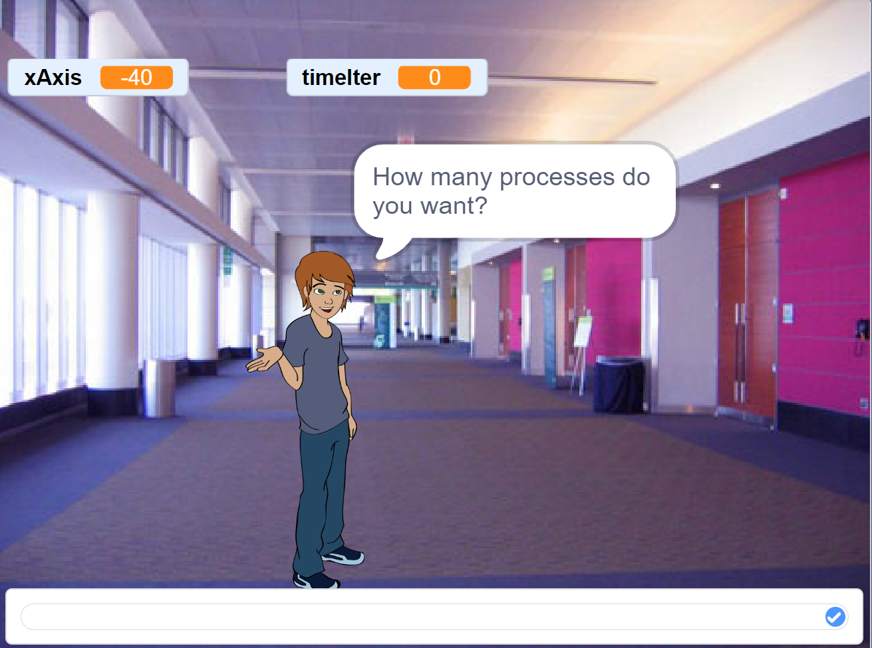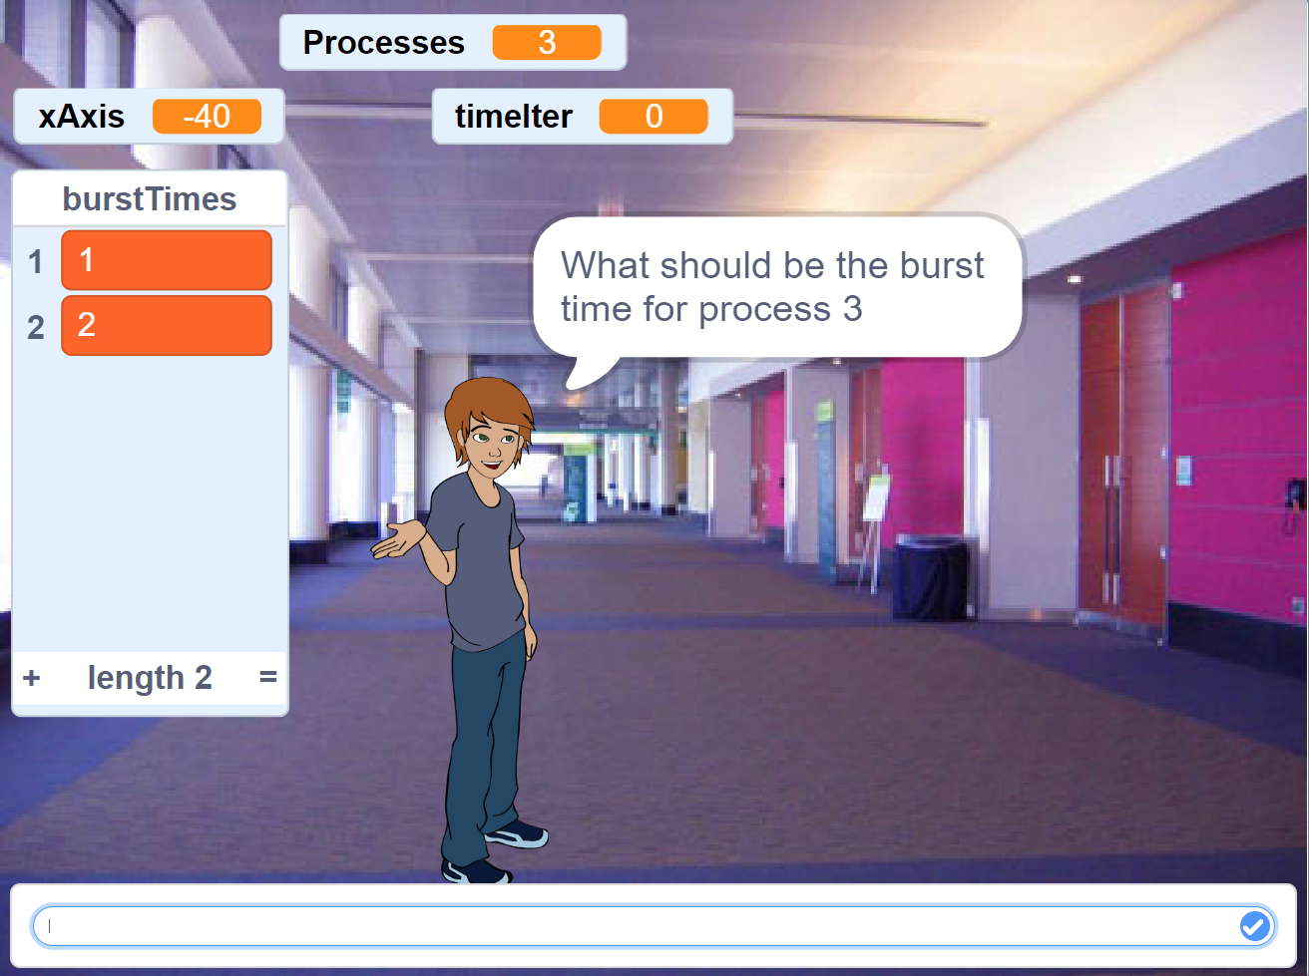

This is the first part, where the user decides the number of desired processes and the time quantum. The burst values are also customizable. After the user inputs the required data, the visualization process is initiated and the following graphic is loaded:

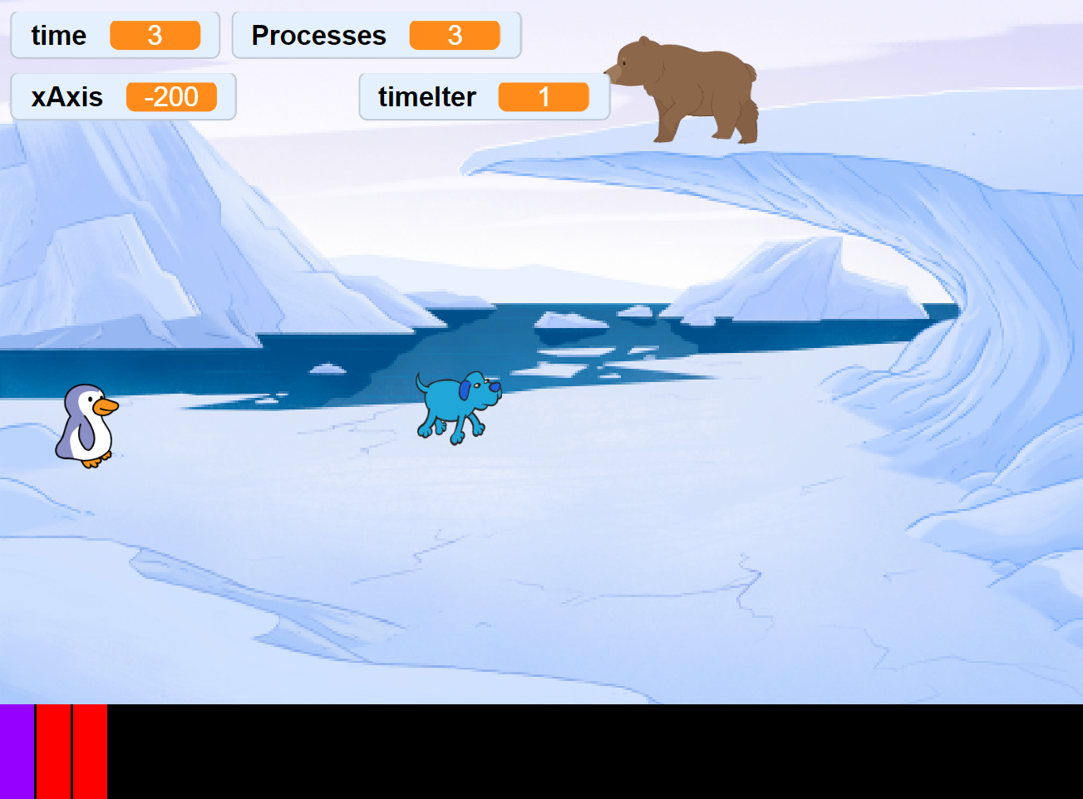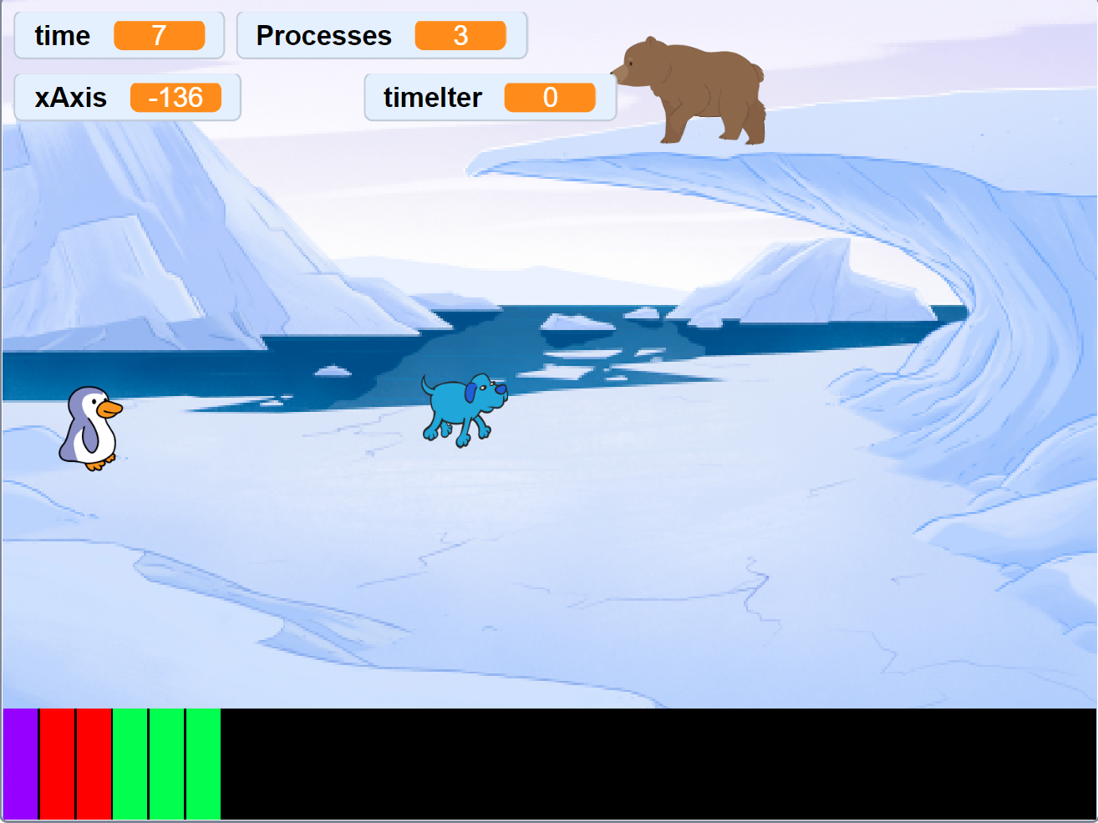

The status bar at the bottom indicates the number of processes completed.

Each color is for a single process. If the burst value exceeds the time quantum, the remaining part of the process is completed in the next cycle.

The sprites ( the animals) standing there indicate the processes as well.

Troubleshoot:

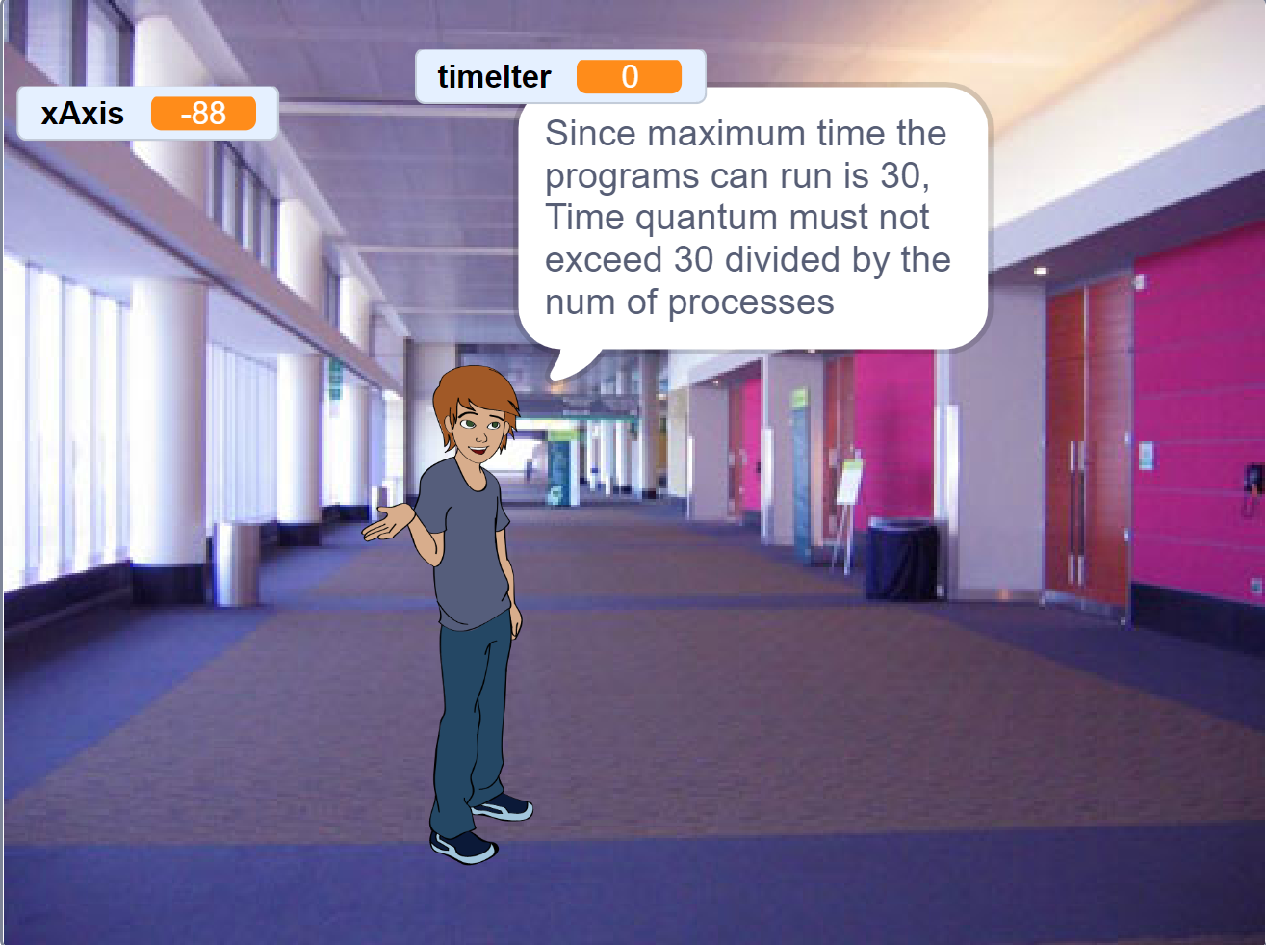

If the time quantum variable entered by the user is greater than 30, then the above shown error is displayed. The time quantum must not exceed 30 divided by the number of processes.

Thank YOU